Test –Biology [Ch: 1 &2]

Class-12th[E.M]

//// ACADEMY

Time: $2$ Hours

Total Marks-40

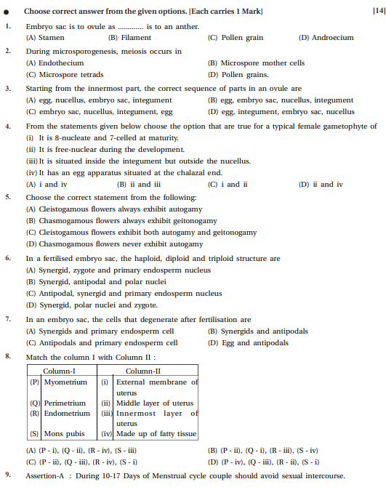 Part-A [14 Marks]

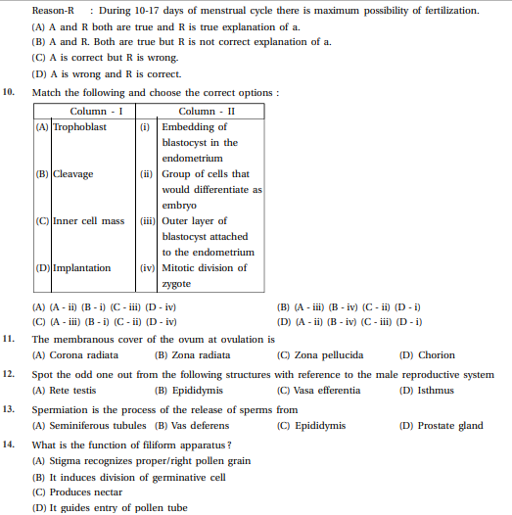15. After ovulation Graafian follicle regresses into  
(a) corpus atresia b) corpus callosum  
(c) corpus luteum d) corpus albicans

Part-B [25 Marks]

**🡪Each question carries 2 marks [8]**

1. Why does the zygote begin to divide only after the division of Primary Endosperm Cell (PEC) ?
2. Give information about the structure and location of oviducts.
3. Describe the contraceptive techniques which are highly effective but with very poor reversibility.
4. In eukaryotes, explain splicing and tailing (figure is not necessary).

**🡪Each question carries 3 marks [9]**

1. Draw the diagram of a microsporangium and label its wall layers. Write briefly about the wall layers ?
2. ‘There is a paternity dispute for a child’. Which technique can solve the problem. Discuss the principle involved.
3. Draw a diagrammatic sectional view of a seminiferous tubule in humans and label its parts. Explain it.

**🡪Each question carries 4 marks [8]**

Explain the process of spermatogenesis.

Describe the structure of Megasporangium with a diagram.

*ALL THE BEST*

*3*